Project Name : **AQARY** is a Cross-platform apps are software applications developed for property advertisement related to the real estate companies, which any customer can browse and book or make interest of a property unit.  
  
  
**The Entities :**  
Real estate companies  
Customers accounts  
Property units

Government areas   
Advertisement

Booking

**Relations:**  
Real estate companies Create the ads  
Customers can book a units  
Units are exist in a government area.  
**ERD: ====> The Link ERD and It will improve( Github) =🡺** [**ERD** **- AQARY**](https://github.com/mohamed-719/erd-aqary.git)

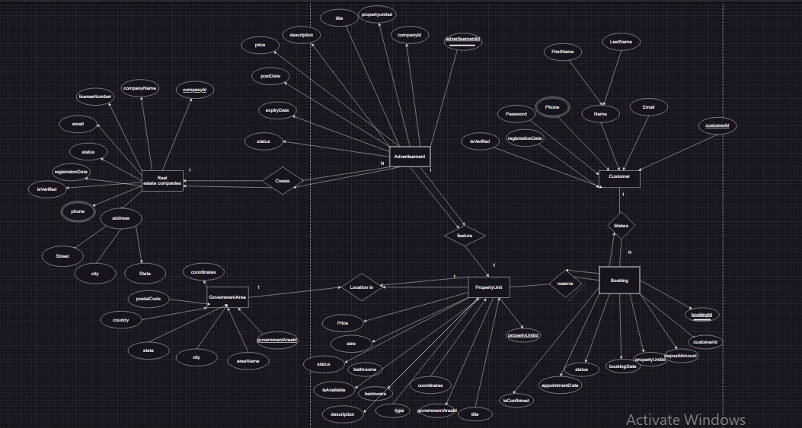  
  
**Team members :**  
1: Mohamed Salah Abdullah  
2: Mohamed Fathi Khalifa  
3: Mahmoud khaled Mustafa

**diagram of AqaryDB:**

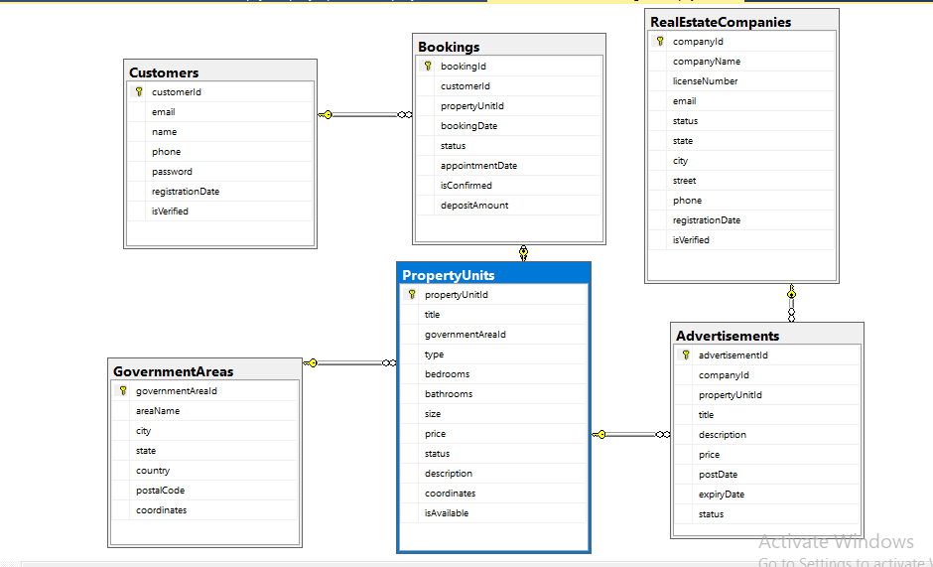

**Tables:**

